**Nintendo vs. Third-Party**

Every F statistic calculated for the difference in mean Metacritic scores and sales had a hilariously small P value meaning there was a very low probability that the difference in means would be as extreme as they were. There are far too many publishers to perform a reasonable ANOVA test for the difference in means, even after reducing the smaller ones to an “other” group. I mentioned earlier that the exclusivity variable also had didn’t work being compared to sales because exclusives will inherently sell less on an individual console.

This Nintendo vs third party section overcomes those shortcomings in a way that is relevant for a Nintendo console. Games talk about how great Nintendo’s games are, how they only buy Nintendo console’s for their games, and how there are no third-party games on their consoles. So let’s take a look into this in detail.

The data are separated by Nintendo and third-party. Then the third-party group is further separated into third-party exclusives and third-party multiplatform. These are the abbreviated names used in the R code.

Nintendo = nin

Third-party = tp

Third-party exclusive = tpx

Third-party multiplatform = tpm

**Third Party Exclusive VS Third-Party Multiplatform**

There was no write up about the relationship between exclusivity and sales in the bivariate analysis. Exclusives will obviously sell more on a specific console because their total sales are not spread out between two or three consoles. When looking specifically at third-party exclusives compared to third-party multiplatform games, the difference in sales was much smaller and sometimes not significant for the different regions.

Exclusive games (including Nintendo) sell about 600,000 more copies than third-party multiplatform games equating to a significantly high T-statistic of 5.29 with a P-value of 4.969e07. However, third-party exclusives (excluding Nintendo) only sell about 110,000 more copies than third-party multiplatform equating to a T-statistic of just 1.89 with a P-value of .063.

This means that exclusives sell a lot more on the Gamecube than multiplatform games like they should, but that is mostly because Nintendo’s games sell very well. When just looking at third party exclusives to multiplatform games, exclusives are expected to sell an extra 110,000 copies on the Gamecube by staying exclusive to the platform.

The difference in quality was also taken into account. Exclusive games have the potential to look and run better than multiplatform games because resources are not spent in porting the game to different consoles. Using the Metacritic score variable to measure quality, the third-party multiplatform games actually outscored the third-party exclusives, but only by 2 points. The mean for multiplatform games also benefits greatly by the yearly releases quality EA sports games. When the number of those games is reduced, the means become more equal. This means that third-party exclusives are not seen as being “better” games and therefore are not getting a boost in sales on the Gamecube because of the extra potential for quality.

**Nintendo VS Third Party**

Nintendo’s games out-reviewed and out-sold third-party games party games by a significantly large margin. Anyone who follows the video game industry probably expected this outcome.

Nintendo Metacritic score vs third-party Metacritic score

t.test(x = nin$Metacritic.Score, y = tp$Metacritic.Score, na.rm=T)

##   
## Welch Two Sample t-test  
##   
## data: nin$Metacritic.Score and tp$Metacritic.Score  
## t = 5.452, df = 62.991, p-value = 8.855e-07  
## alternative hypothesis: true difference in means is not equal to 0  
## 95 percent confidence interval:  
## 5.915233 12.760553  
## sample estimates:  
## mean of x mean of y   
## 77.53061 68.19272

Nintendo total sales vs third-party total sales

t.test(x = nin$Sales.Total, y = tp$Sales.Total)

##   
## Welch Two Sample t-test  
##   
## data: nin$Sales.Total and tp$Sales.Total  
## t = 5.6177, df = 50.367, p-value = 8.374e-07  
## alternative hypothesis: true difference in means is not equal to 0  
## 95 percent confidence interval:  
## 0.8303885 1.7543959  
## sample estimates:  
## mean of x mean of y   
## 1.5311765 0.2387843

(Difference in sales for the individual regions were also significant in Nintendo’s favor)

The correlation between Metacritic score and sales when separating Nintendo and third parties is worth taking a second look. Nintendo’s games sell and review so differently that the relationship between the two variables might be different for their games compared to third-party games. I mentioned earlier that the correlation between the two variables is a fairly weak .3. When looking specifically at third-party games, the correlation remains in the same area with a score of .31, but the correlation jumps up to .48 for Nintendo’s games. Keep in mind that there are many more third-party games than Nintendo games making the third-party correlation much closer to the correlation of the total set of games. This means that Gamecube owners care much more about the quality or they are more likely to make purchasing decisions based on reviews when it comes to Nintendo’s games.

**Nintendo VS Third Party Exclusive**

Third-party multiplatform games must be excluded to perform a fair test comparing the total sales of Nintendo’s games to third-party games. Even though third-party exclusives did not sell significantly more than multiplatform games, exclusivity still mediates that relationship.

Nintendo vs third-party exclusive sales

t.test(x = nin$Sales.Total, y = tpx$Sales.Total)

##   
## Welch Two Sample t-test  
##   
## data: nin$Sales.Total and tpx$Sales.Total  
## t = 5.0774, df = 55.989, p-value = 4.538e-06  
## alternative hypothesis: true difference in means is not equal to 0  
## 95 percent confidence interval:  
## 0.7266258 1.6736219  
## sample estimates:  
## mean of x mean of y   
## 1.5311765 0.3310526

Even after removing the third-party games that will sell fewer copies, Nintendo’s games still sell significantly better.

The correlation between Metacritic score and Sales for third-party exclusive games is .43 which is much closer to the .48 score that Nintendo games got. This refutes the earlier conclusion that the Gamecube owners care more about quality and review scores for Nintendo games.

**Support over the Years**

Looking back at the release year variable, there was a noticeable drop in support from the year 2003 to 2004. With the newly separated data, it is now possible to see what happened in better detail.

Third-party multiplatform games make up a majority of the game library, so the proportion of total releases was observed instead of the raw number. The purpose is to look at when the most and fewest number of games were released based on the total amount of games released throughout the console’s lifecycle. Evenly sized bars means that a consistent number of games were released each year. Discrepancy in size shows a shift in the number of games released. Also keep in mind that 2001 only accounts for the last 4 months of that year so that bar should be much lower than the others.

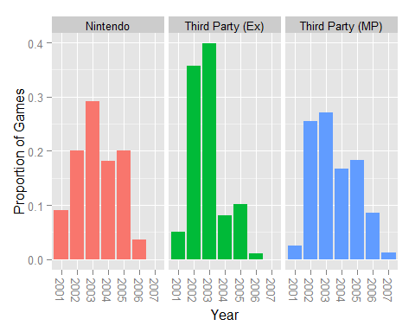

The main point is the difference in height between the 2003 bar and the 2004 bar. It drops for each group like the graph in the earlier section, but the largest drop is with the third-party exclusives. Nintendo continued publishing games because they don’t really have much of a choice. Third-party companies still decided the console was worth porting games to. It was the third-party exclusives that were lost in 2004. Exclusives did not sell that much more on the Gamecube as shown in the earlier T-test. By 2004, third-party companies were done missing out on extra revenue they could get from the Playstation 2 and Xbox audiences.

**Metacritic Score VS Sales**

The relationship between these two variables deserves another look because it changed after separating out the different groups. It was first believed to be a weak relationship with a correlation coefficient of about .3, but that relationship is much stronger with the exclusives in the .4-.5 range.

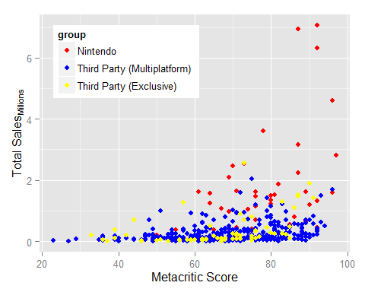

The Multiplatform games (blue points) make up the majority of the library of games. It is also expected that they make up the majority of the lower portion of the graph as their sales total sales are essentially cut by 1/2 or 1/3 by being multiplatform. There is still a positive relationship that can be seen with a few of the higher rated games rising above the pack, but there are still many more quality games that didn’t sell well which weakens the relationship (the blue points in the bottom right corner). Some of those are yearly releases of sports titles from Electronic Arts that are released yearly and maintain a high quality, but are not popular among Gamecube owners. It is also possible that people who owned multiple consoles that generation bought those sports games on PS2 or Xbox.

Earlier it was discovered that third-party exclusives don’t sell significantly better than the third party multiplatform games. This graph is visual evidence of that. Third-party exclusives are the yellow points that mostly overlap the blue points. The yellow points are basically in the same area as the blue points with the exception of a few higher rated games succeeding.

Nintendo’s games are the red points which are the only games that sold above the 2.5 million mark. There games perform so much better that *Kirby’s Air Ride* sold 1.62 million copies with a Metacritic score of 61 while *Bomberman Generation* sold 250,000 with a Metacritic Score of 81. That’s just one example and isn’t the case for the entire population, but the graph clearly shows which of games sell and which games don’t.